**Gate Level:**

**Verilog Module:**

`timescale 1ns / 1ps

//////////////////////////////////////////////////////////////////////////////////

// Company:

// Engineer:

//

// Create Date: 21:53:38 10/16/2022

// Design Name:

// Module Name: AND

// Project Name:

// Target Devices:

// Tool versions:

// Description:

//

// Dependencies:

//

// Revision:

// Revision 0.01 - File Created

// Additional Comments:

//

//////////////////////////////////////////////////////////////////////////////////

//2020-CE-121 Zahir Khan

module AND(

input a,

input b,

input c,

output y,

inout e,

inout f,

inout g

);

and(e,a,b);

and(f,e,c);

and(g,e,~c);

or(y,f,g);

endmodule

**Text Fixture:**

`timescale 1ns / 1ps

////////////////////////////////////////////////////////////////////////////////

// Company:

// Engineer:

//

// Create Date: 12:29:40 01/23/2023

// Design Name: AND

// Module Name: D:/Xilinx/Workspace/Lab1/TF.v

// Project Name: Lab1

// Target Device:

// Tool versions:

// Description:

//

// Verilog Test Fixture created by ISE for module: AND

//

// Dependencies:

//

// Revision:

// Revision 0.01 - File Created

// Additional Comments:

//

////////////////////////////////////////////////////////////////////////////////

module TF;

// Inputs

reg a;

reg b;

reg c;

// Outputs

wire y;

// Bidirs

wire e;

wire f;

wire g;

// Instantiate the Unit Under Test (UUT)

AND uut (

.a(a),

.b(b),

.c(c),

.y(y),

.e(e),

.f(f),

.g(g)

);

initial begin

// Initialize Inputs

a = 0;

b = 0;

c = 0;

// Wait 100 ns for global reset to finish

#100;

// Add stimulus here

// Initialize Inputs

a = 0;

b = 0;

c = 0;

// Wait 100 ns for global reset to finish

#100;

a = 0;

b = 0;

c = 1;

#100;

a = 0;

b = 1;

c = 0;

#100;

a = 0;

b = 1;

c = 1;

#100;

a = 1;

b = 0;

c = 0;

#100;

a = 1;

b = 0;

c = 1;

#100;

a = 1;

b = 1;

c = 0;

#100;

a = 1;

b = 1;

c = 1;

end

endmodule

**Schematic:**

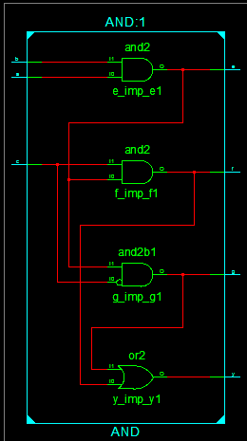

**WaveForm:**

